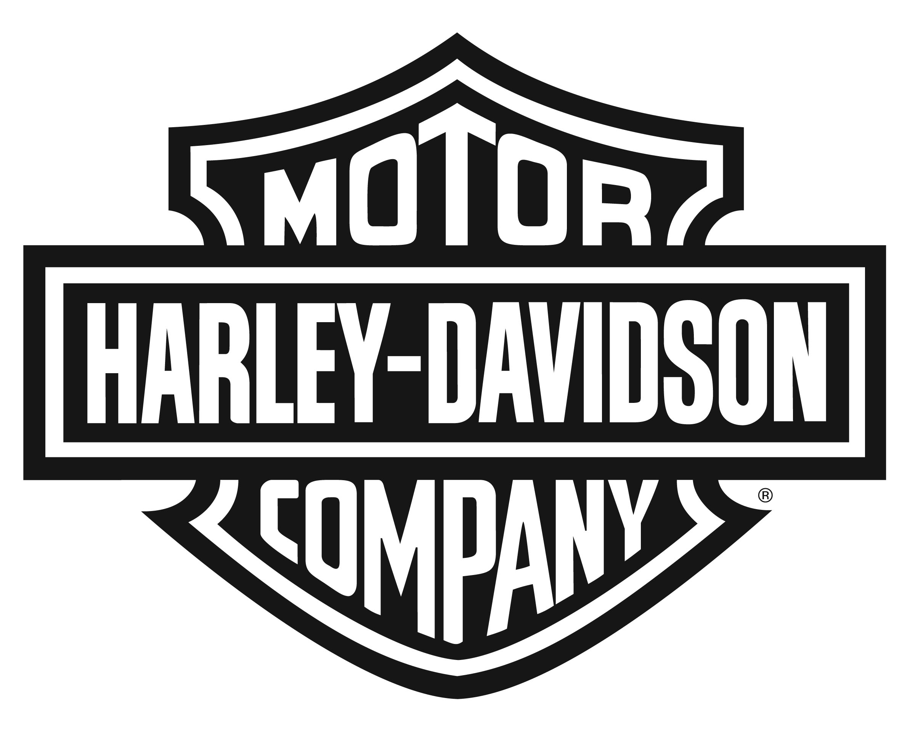

Harley-Davidson Motor Company 3700 W. Juneau Ave., P.O. Box 653, Milwaukee WI 53201

NEWS

Contact: Jen Hoyer (414) 343-7092, jennifer.hoyer@harley-davidson.com

FOR IMMEDIATE RELEASE

HARLEY-DAVIDSON ROADSTER OPENS A NEW CHAPTER IN SPORTSTER STORY
New Roadster Model is Stripped to the Essentials of Form and Function

MILWAUKEE (April 18, 2016) – Shaped by nearly 60 years of heritage and stripped to the essential elements of a pure riding machine, the new Harley-Davidson® Roadster™ motorcycle is at home in urban landscapes and on twisting roads and makes a bold visual statement even when standing still.

“Since its introduction in 1957, the Harley-Davidson Sportster has proved capable of constant reinvention, and the Roadster writes a new chapter in that story,” said Harley-Davidson Director of Styling Brad Richards. “We’ve watched our customers take the Sportster in so many different directions. The Roadster is a mash-up of styling genres, but the intent was to build a rider’s motorcycle, a Sportster that’s lean and powerful and connects the rider to the road.”

The new Roadster model, which is featured in Harley-Davidson’s current Live Your Legend marketing campaign, joins the Dark Custom lineup with a minimalist design inspired by classic racing motorcycles and current trends in stripped-down, naked custom bikes and a profile reminiscent of racing Sportster motorcycles from the 1950s and 1960s.

“We wanted to give the Roadster some DNA from the high-performance KHR models of the mid-50s, and later Sportsters tuned for the drag strip,” said Richards. “Those bikes had fenders cut to the struts, the small fuel tank, and were stripped to their bare essentials to achieve a singular performance purpose.”

The Roadster delivers modern performance with a combination of new wheels and tires mated to premium suspension components and an air-cooled 1200cc V-Twin engine that delivers a strong pulse of mid-range torque. The 19-inch front and 18-inch rear Offset-Split 5-Spoke cast aluminum wheels were designed specifically for the Roadster and contribute to its balanced, athletic stance.

“The wheels were inspired by classic laced wheels, and are the most intricate cast wheel we’ve ever created,” said Harley-Davidson Industrial Designer Ben McGinley. “The interlacing spokes shoot outward toward opposite sides of the wheel, creating a dramatic visual effect. These wheels are also very light for their size, which contributes to the Roadster’s handling performance.”

The Roadster’s suspension is enhanced by new 43mm inverted single-cartridge forks with tri-rate springs, gripped in robust triple clamps and rear suspension featuring gas-charged emulsion coil-over shocks and tri-rate springs with adjustable pre-load and offers greater suspension travel than any other Sportster model – 4.5 inches in front and 3.2-inches in the rear. Outstanding stopping power is achieved with dual 11.8-inch floating rotors on the front wheel. The Roadster is available with optional ABS brakes.

The Roadster puts its rider in an aggressive posture with a new low-rise handlebar and mid-mount foot controls that center the rider’s weight over the classic profile of the 3.3-gallon Sportster fuel tank.

In keeping with the Roadster’s stripped-down styling, the rear fender has been clipped 1.5 inches shorter than previous bobbed Sportster fenders. The slotted belt guard and muffler shields mimic the lightening holes drilled through race-bike components and a single four-inch diameter instrument tucked low in front of the triple clamp features a sweeping analog tachometer with an inset digital speedometer. Rear turn signals mounted directly to the fender struts, a side-mount license plate and fast-back seat design give the rear of the bike a tight and uncluttered look.

“The seat’s profile flows into the very short rear fender,” said McGinley. “The cover features a series of pads inspired by an armored leather jacket, and the rear of the seat is designed as a passenger pillion, to give the Roadster added versatility.”

The Harley-Davidson Roadster model will be offered in four color choices: Vivid Black with a charcoal denim pinstripe; Black Denim with a red pinstripe; Velocity Red Sunglo with a red pinstripe; and two-tone Billet Silver/Vivid Black with a burgundy pinstripe.

Visit H-D.com to see all 2016 Harley-Davidson® models and to find a local authorized Harley-Davidson® dealer.
About Harley-Davidson Motor Company
Since 1903, Harley-Davidson Motor Company has fulfilled dreams of personal freedom with cruiser, touring and custom motorcycles, riding experiences and events, and a complete line of Harley-Davidson® motorcycle parts, accessories, general merchandise, riding gear and apparel. For more information, visit www.h-d.com.

###

